Liver cancer
In this section, we will describe the anatomical properties of the liver and the major public health problem caused by liver cancers. This section allows us to see the potential value brought by our work regarding the treatment of liver cancer.
After a small introduction about the different types of liver cancers, we will focus on the most common primary one: the Hepatocellular Carcinoma. We will review its risk factors, and the way it develops in the liver, before exposing the different invasive or non-invasive ways to establish a clear diagnosis of the disease. Finally we present the different staging systems and treatments available to provide the better chance of survival to the diseased patients. A precise description of the different stages of the disease and the subsequent pathological changes is necessary in order to understand how our work can further be incorporated in the clinical practice.

The liver is a key organ in the human body, responsible for the synthesis of several proteins, and playing a major role during the digestion, particularly with the production of bile that is further stored in the gallbladder. It is also essential for the breakdown of numerous hormones, and it has a central position in the human blood flow system with its unique dual blood supply, being one of the 3 only portal systems of the human body and the only venous one.
Being a key organ, the liver can suffer from various pathologies, which include liver cancer, that is now considered as a major public health challenge with its high incidence and mortality rates. In their latest statistical report, the World Health Organization ranked it as the fifth cancer type in terms of incidence with about 841,000 new cases annually, and as the fourth cause of cancer-related deaths worldwide, with about 782,000 annual deaths. Mortality and incidence rates are between 2 and 3 times higher among men than women in most regions of the world, making it the second type of cancer in terms of deaths for males. [Bray et al. 2018]
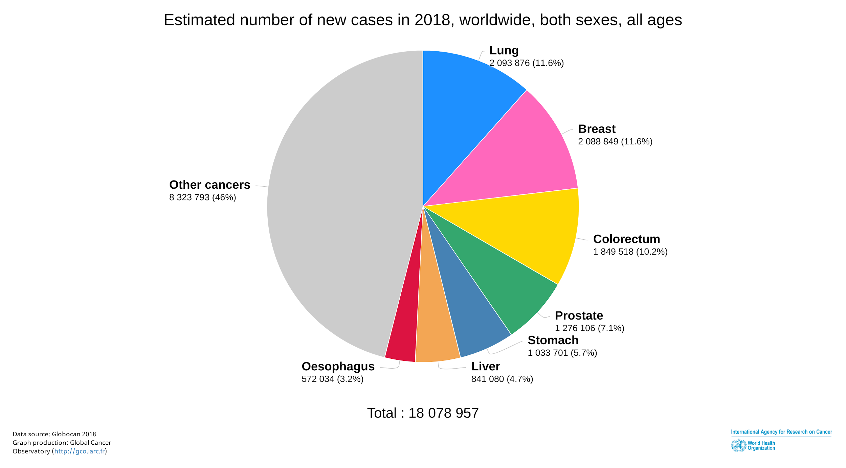
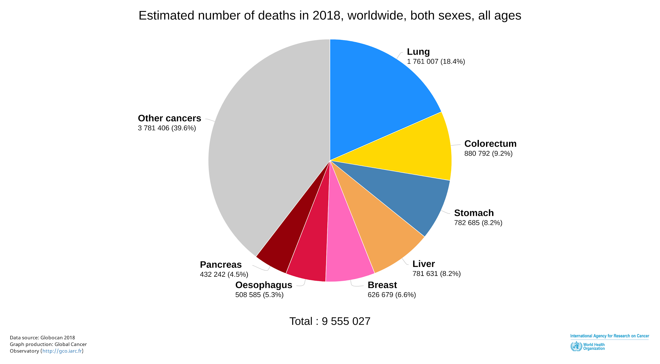
The liver cancer can either be referred to as primary, meaning that it is originally growing in the liver itself, or as secondary, in case of extrahepatic cancers that metastases in the liver.
In case of metastases, cancerous cells often originate from the lung, the breast, and some parts of the digestive system, such as the colon, with the colorectal cancer being the main source of extrahepatic metastases. [ref Hoyer et al. 2012, Sahani et al. 2014]
Even though secondary liver cancers are more frequent than primary ones, we have decided to focus on the latter to analyze the entire process from the appearance of the malignant cells to the physiological changes. Indeed, analyzing secondary liver cancers requires a complete understanding of the alterations in the primary site that led to it.
Primary liver cancers comprise hepatocellular carcinoma (HCC), intrahepatic cholangiocarcinoma (iCCA), mixed hepatocellular cholangiocarcinoma (HCC-CCA) and other rare tumors, notably fibrolamellar HCC (FLC) and pediatric neoplasm hepatoblastoma [ref Sia et al. 2017 + ref 4-5].
HCC accounts for nearly 90% of primary liver cancers, with the highest incidence in Asia and in the Sub-Saharan countries, mainly due to the high prevalence of hepatitis B virus (HBV) [ref Sia et al. 2017 + ref 6]. The second most common one is iCCA, with a noticeable high incidence in Southeast Asian countries, and mainly developed in patients with primary sclerosing cholangitis (PSC), biliary duct cysts, hepatolithiasis, or parasitic biliary infestation with flukes. [ref Sia et al. 2017 + ref 13].
The high incidence of HCC leads us to focus our research work on this specific cancer type. We will now detail its risk factors, development, diagnosis methods and treatment techniques.

Hepatocellular Carcinoma

Risk factors
The main reason leading to HCC is the cirrhotic status of the liver, but its development is often related to the presence of other chronic liver diseases.
Its incidence is heterogeneous worldwide because of the variable prevalence of risk factors: most cases occurring in sub-Saharan Africa and eastern Asia are associated with HBV and aflatoxin B1 exposure. In the USA, Europe and Japan, Hepatitis C (HCV) and the excessive alcohol consumption are the main risk factors [ref Fornet et al. 2019].
Other risk factors include the presence of non alcoholic-fatty liver disease (NAFLD), obesity and diabetes [ref Marengo et al. 2016].
NAFLD was defined about 20 years ago, and regroups a spectrum of progressive liver diseases that encompasses simple steatosis, nonalcoholic steatohepatitis (NASH) and ultimately cirrhosis [ref Marengo et al. 2016]. It has been identified as the underlying cause of patients presenting with HCC unrelated to virus and alcohol [ref 3 of Marengo et al]. Several other studies confirmed that NAFLD is a risk factor for patients with either noncirrhotic liver [ref 33, 30 of Marengo et al] or cirrhotic liver [ref 36, 64, 70 of Marengo et al].
Obesity has been established as a risk factor for several types of cancer, including liver cancer, and a study on 900,000 American adults reported a mortality rate five times higher in patients with a body mass index of 35 kg/m² compared to the group with a normal BMI [ref 1 of Marengo et al.]. Several other studies were conducted to show the relation between HCC and obesity in the UK, Korea, Sweden, Taiwan and also a multicentric European study [ref 10, 11, 12, 16, 14 of Marengo et al.].
Diabetes has also been identified as an independent risk factor for HCC [ref Fornet et al. 2018], especially types 2 diabetes [ref 21, 19, 18, 22, 17 of Marengo et al.]

Development

Cells of origin of liver cancer
The basic hepatic cells are divided into parenchymal (hepatocytes, which constitute between 60 and 80% of the total liver mass, and cholangiocytes as depicted in the figure below) and non-parenchymal cells (fibroblasts, stellate cells, Kupffer cells, and endothelial cells) [ref Sia et al. 2017].
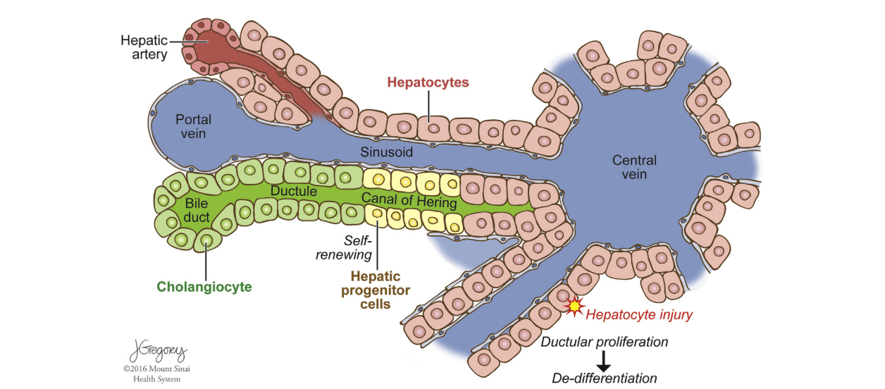
The two main primary liver cancers types, HCC and iCCA have been considered to be distinct tumors that originate from specific cell populations. Nonetheless, they have recently been recognized as subtypes of a continuous spectrum of diseases. Therefore, several hypotheses exist about the cells of origin of the different primary liver cancer [ref Sia et al. 2017].
One of them suggests that liver tumors can be generated by hepatic progenitor cells, since during liver development, both hepatocytes and cholangiocytes both arise from a common progenitor as depicted below. However, both tumor subtypes can also arise distinctly from mature parenchymal cells [ref Sia et al. 2017].
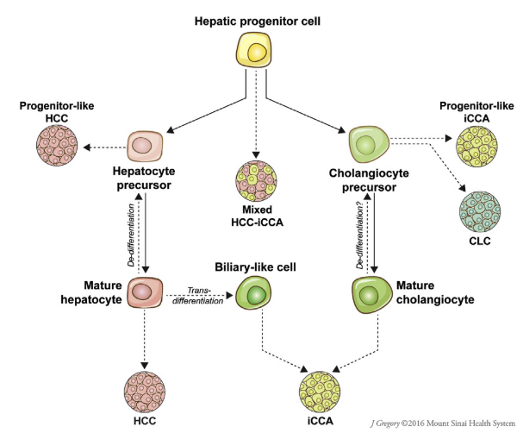
This latest hypothesis is the one that we will describe in the following, and we will focus specifically on the development of HCCs.

Hepatocarcinogenesis
The main process behind the evolution of HCC is called hepatocarcinogenesis, which is
defined as the progressive transformation of nonmalignant liver cells into HCC. [ref Choi et al. 2014]
This transformation from nonmalignant liver cells into HCC is not fully understood, but the chronic inflammation present in the liver results in cycles of cell injury-death-regeneration, that stimulate epidemic changes and accumulation of genetic damages [ref 11, 20-22 of Choi et al.]
The high inter and intra-patient heterogeneity that exists for HCCs is explained by the fact that several molecular variants of HCC may be produced, among the patients population, and even within different regions of the same tumor [ref 22, 27 of Choi et al.]
The hepatocarcinogenesis is outlined by the gradual de-differentiation of abnormal nodular lesions, as described in the figure below [ref 18,19 of Choi et al.] Over time, the more differentiated surrounding tissues are replaced by the growing less differentiated ones.
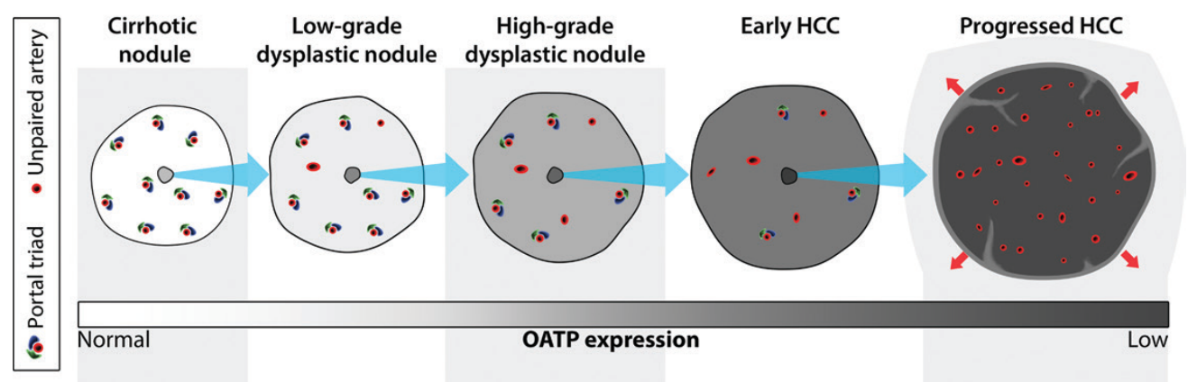
It is possible that HCCs may arise from malignant cells without following this process, and without transitioning through histologically definable intermediate steps the process is then referred to as “denovo hepatocarcinogenesis” [ref 31 of Choi et al.].
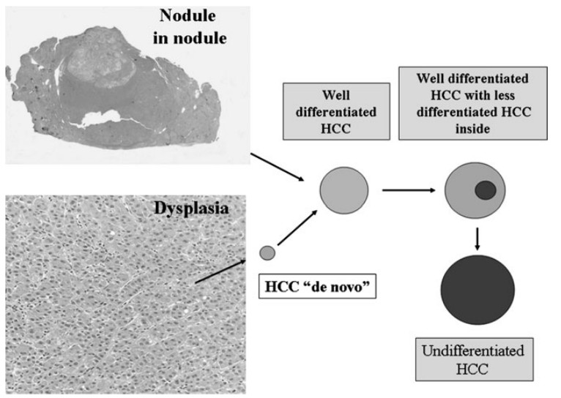
As depicted in the figure above, hepatocarcinogenesis is composed of several steps, where each stage presents specific characteristics:
- Cirrhotic nodules are well-defined rounded regions of cirrhotic parenchyma surrounded by scar tissue and measuring less than 15 mm in diameter [ref 30 of Choi et al.]. Even though they are usually considered as non-malignant, hepatocytes that they contain may develop dysplastic features, thus transforming the cirrhotic nodules into a dysplastic foci or nodules.
- Dysplastic foci are not identified via in vivo imaging, but may be recognized histologically. They are not well understood and may develop into dysplastic nodules.
- Dysplastic nodules correspond to nodular lesions that differ macro and microscopically from the surrounding parenchyma. They are observed in 25% of cirrhotic livers, and can be classified into low-grade (that appear like cirrhotic nodules) or high-grade (more similar to well-differentiated HCCs)
- Early HCCs grow gradually by replacing the parenchyma, unlike apparent progressed HCCs that displace or destroy the liver parenchyma. During their evolution, they tend to surround structures like portal tracts or central veins without destroying them.
They are microscopically indistinguishable from high-grade dysplastic nodules, since they tend to be vaguely nodular without having capsules nor distinct margins.
Even if they are considered as ancestors of progressed HCCs [ref 19 of Choi et al.], their progression rate is not clearly defined [ref 39 of Choi et al.]
TO REMOVE: As described later, the hepatobiliary phase MR imaging is one of the only imaging modality that tends to show promise for detecting them.
- Progressed HCCs are generally separated between those measuring less than 2cm and those larger than 2cm.
  - Those smaller than 2cm tend to be nodular with a well-defined margin. They are different from early HCCs in the way that they grow by expanding into and compressing the adjacent parenchyma. They tend to be histologically moderately differentiated in the vast majority of the cases, and are associated with vascular invasion and intrahepatic metastasis [ref 19 of Choi et al.]
  - The large progressed HCCs tend to have a more aggressive biological behavior, and are associated with a higher histological grade, with a higher presence of vascular invasion and metastasis.
They are histologically composed of poorly differentiated or undifferentiated cancer cells that spread into the surrounding sinusoids, thus often characterized by an ill-defined boundary [ref 4 -11 of Choi et al.]
- Multifocal HCC can be the result of a synchronous development of several independent liver tumors originating from a primary tumor [ref 11 of Choi et al.], knowing that patients with HCC are at higher risk of developing new tumors.

These several steps defining hepatocarcinogenesis are most of the time accompanied by some pathophysiological alterations:
- Angiogenesis: that is histologically characterized by the development of unpaired (or nontriadal) arteries as depicted in the Figure “hepatocarcinogenesis steps” and the transformation of hepatic sinusoids into continuous capillaries, a.k.a “sinusoidal capillarization” [ref 28-29 of Choi et al.]
Besides these changes, the portal tracts, containing both the non-tumoral hepatic arteries and the portal veins, progressively decrease [ref 47 of Choi et al.].
Whereas the portal inflow to the nodule diminishes, the formation of unpaired arteries causes an increase in arterial flow [ref 28-29 of Choi et al.]. This difference in blood inflow is such that we observe a total inversion of tendency during the hepatocarcinogenesis, with a decrease of arterial flow accompanied by a preservation of portal venous flow in the early phases, and a decrease of portal blood flow with an increase of arterial flow in the later phases, as depicted in the figure below:
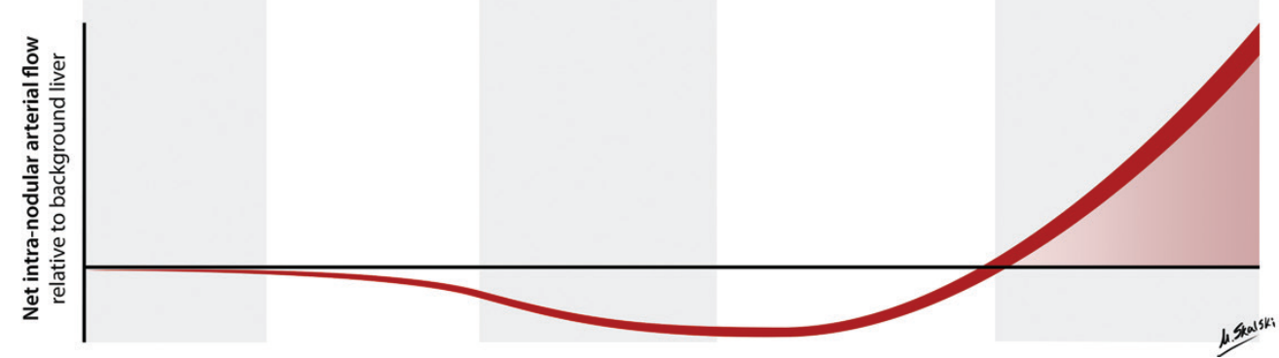
- Venous drainage: During hepatocarcinogenesis, the way the blood is drained by the lesions is subject to modifications as depicted in the figure below [ref Kitoa 2009].
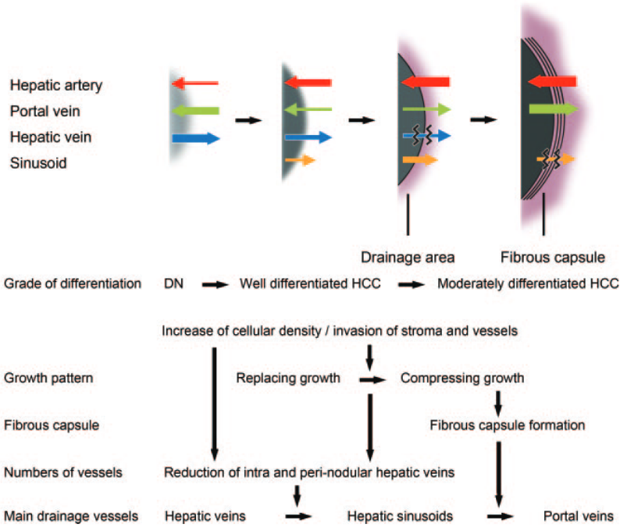
First, the blood is evacuated via hepatic veins, then sinusoids are used and replace the hepatic veins that start to be blocked. Later during the process, the sinusoids start to collapse and the blood cannot be delivered through this way, therefore, the only remaining way is through the portal veins [ref 50-51 of Choi et al.].
This change along the disease progression may explain the phenomenon of corona enhancement, which appears mainly on progressed hypervascular HCC, and which referred to an enhancement of the peritumoral parenchyma starting a few seconds after the enhancement of the tumor. Worth noting that early HCCs are not concerned by this phenomenon [ref 52 of Choi et al.]
- Tumor Capsule and Fibrous Septa: are observed in about 70% of progressed nodular HCCs [ref 42 of Choi et al.], with a capsule consisting of two distinct layers.
Some studies have shown that tumors with an intact capsule were associated with a lower recurrence rate than those without (tumors of similar size), suggesting that the capsule may retard the tumor dissemination, especially the tight inner layer that might act as a physical barrier [ref 57 of Choi et al.]
Even though advanced HCCs with an intact capsule have a more favorable prognosis than HCCs of the same size without any capsule, they have a worse prognosis than early HCCs that are unencapsulated [ref 59 of Choi et al.]
- Fat content: It has been demonstrated that hepatocytes may accumulate fat during the early phases of hepatocarcinogenesis, causing the tumors to be more steatotic.
This steatosis is highly frequent for early HCCs of about 1.5 cm in diameter, but decreases when the size and the grade of the tumor increases. This might probably be because unpaired arteries become more developed once the tumor progresses, resolving ischemic conditions, and provoking the regression of steatosis [ref 47, 61 of Choi et al.]
- Iron content may accumulate early in the process of hepatocarcinogenesis, noticeable essentially in low or high grade dysplastic nodules [ref 33 of Choi et al.]. In the later stages, hepatocytes become resistant to iron accumulation due mainly to the utilization of iron by neoplastic cells and a higher cellular proliferation, thus early and progressed HCCs are often iron free [ref 65 of Choi et al.].
- Diminution in the expression of OATP Transporters. Some of these transporters belonging to the OATP (Organic anionic transporting polypeptides) group are thought to be responsible for the uptake of two hepatobiliary-specific gadolinium-based contrast agents, namely the gadoxetate disodium and gadobenate dimeglumine.
Their expression level tends to be inversely proportional to the advancement of the disease [ref 67, 69 of Choi et al.]
The different alterations are often the results of early or more advanced stages of hepatocarcinogenesis. They can appear individually or can be combined within the same tumor.
However, the HCC can often later spread either intra or extra-hepatically:
- Intrahepatic metastasis: corresponds to one of the most important spread mechanisms of progressed HCCs, and occurs mainly when malignant cells enter portal venules that drain the primary tumor, before spreading into the surrounding parenchyma.
These metastases around the primary tumor in the form of small satellites, and are located within its venous drainage area [ref 74 of Choi et al.]. Even though malignant cells can easily invade vessels, extrahepatic metastases occurring in organs such as the lungs, the lymph nodes, the bones or the adrenal glands, are late manifestations of the disease [ref 6, 11 of Choi et al.]
- Vascular invasion: is a late manifestation of hepatocarcinogenesis, affecting mainly the progressed HCCs [ref 77 of Choi et al.], and allows a distinction between primary and secondary liver cancers which uncommonly present an invasion of intrahepatic vessels [ref 76 of Choi et al.]
These invasions are either classified as micro or macroscopic, and usually are accompanied by a poor prognosis, as they provide a way for cancerous cells to propagate in the liver or systemically. Moreover, patients suffering from cancers with vascular invasion tend to have a higher recurrence rate after ablation, resection and transplantation, therefore, vascular invasion is often considered as a contraindication for these specific treatments [ref 81 of Choi et al.]
Furthermore, another alteration, called “Tumor Capsule invasion” may increase the risk of vascular invasion, as HCC cells may infiltrate through the tumor capsule into the surrounding parenchyma.

All the changes occurring during hepatocarcinogenesis, leading to a more or less aggressive tumor, or even to multiple tumors, need to be assessed as early as possible to provide the best treatment available to the patient in order to increase its chances of survival.

Diagnosis

Biopsy
One of the standard ways to determine or confirm the cause and the stage of liver disease, as well as to inform treatment decisions and establish prognosis is to perform a biopsy.
This surgical procedure consists of the sampling of typically one fifty-thousandth of the liver volume [ref 1 of Tapper et al.].
The sampled tissues are then reviewed by pathologists, who report the degree of inflammation, steatosis, fibrosis and some other features such as cellular inclusions. The histological assessment is supported by clinicians providing the clinical context to complete the histologic interpretation, and some external blood markers such as the AFP (alpha-fetoprotein) level can be incorporated to attest the presence of a malignant mass [ref Bai et al. 2017 - Zaho et al. 2014 - Heimbach et al. 2017].
This method however suffers from several limitations. Sampling errors are common, as reported by a study where laparoscopic biopsy samples, taken simultaneously from the right and the left lobes of several patients suffering from HCV, were interpreted as cirrhotic in one lobe and fibrotic (F3) in the other in almost 15% of the cases [ref 7 of Tapper et al.]. It has also been proven that the accuracy of both the diagnosis and the staging of the disease highly depend on the size of the specimen, with misinterpretations when too small samples are collected [ref 8 of Tapper et al.].
The interpretation of the samples is very subjective as it has been proven in some studies, with the estimation of both inflammatory activity and fat burden that suffered from a high inter and intraobserver variability [ref 3 of Tapper et al.]. Moreover, being a surgical gesture, the biopsy can suffer from adverse events going from simple pain to death in some rare cases [ref 2, 10-12 in Tapper et al.]. Finally, they happen to be costly since they involve an expert gastroenterologist or radiologist, a pathologist, and need to be performed in facilities with adequate equipment.
Even though biopsy is still used to evaluate the degree of fibrosis or cirrhosis, primary liver cancers are now most often diagnosed on the basis of imaging studies alone in clinical practice. Recent advancements in medical imaging enable the radiologist to discern the cause of focal liver lesions on the basis of vascularity and physiological features, especially through multiphasic, contrast-enhanced, cross-sectional imaging (either computed tomography CT, or magnetic resonance MR).

CT and MR imaging
As explained previously, hepatocarcinogenesis is a long process that can render the tumor very aggressive, and the more the disease evolves, the worse the prognosis will be for the patient, thus an early detection of HCC is critical to improve the survival of affected patients.
The majority of the current guidelines recommend ultrasonography (US) as the primary imaging test for surveillance [ref Choi et al. 2014]. CT and MRI are generally not chosen for surveillance but recommended by some guidelines when the US is limited due to obesity or when the risk factors are very high [ref 13, 14 Choi et al. 2014].
If the surveillance is positive, the main guidelines advocate in favor of multiphasic CT and MR with extracellular agents for the non-invasive diagnosis and staging [ref 4, 12-14 of Choi et al. 2014].
Multiphasic CT and MRI can be categorized by the type of contrast agents used:
- Imaging with extracellular contrast agents permits a diagnosis of HCC based on the physiological changes in the blood flow produced by hepatocarcinogenesis.
Images are typically acquired before (precontrast) and dynamically after the injection of a contrast agent.
The contrast agent is generally administered at a rate of 4-6 mL/sec for CT and around 2 mL/sec for MRI [ref 85-86 of Choi et al. 2014]. The dose is usually adjusted to the body weight, where 1.5-2 mL/kg to achieve an iodine dose of 525 mg/kg of iodine are administered in the case of CT.
Concerning the dynamic contrast enhanced images, three phases are typically acquired, namely the late hepatic arterial, the portal venous, and the delayed phase:
  - The late hepatic arterial phase is characterized by the full enhancement of the hepatic artery with all its branches and an enhancement of the portal vein [ref Choi et al. 2014]. The portal vein is however not supposed to be enhanced by the antegrade flow [ref 87 of Choi et al.].
This phase is critical for the characterization of hypervascular HCCs, since it catches the peak arterial enhancement of tumors [ref 88 of Choi et al.]. The early hepatic arterial phase is often omitted by the centers as only hepatic arteries are enhanced but portal veins are not, which render the detection of hypervascular tumors very difficult. One of the main problems associated with this acquisition is the difficulty to detect the peak arterial perfusion, since fixed delay is often not reliable. Some techniques such as contrast agent bolus tracking, or the selection of the best image after multiple continuous acquisitions may be recommended [ref 90 of Choi et al.].
  - The portal venous phase is characterized by an enhancement of both hepatic artery (arterial) and portal veins. It is however worth noting that the contrast agent still circulates in the body and will still be present in hepatic arteries as well (but with a lower concentration than for the arterial phases).
The portal venous phase is generally acquired at around 60-80 seconds after the start of the injection, but no clear guidelines are given concerning a precise way to determine the best moment for the acquisition of this given phase.
  - The delayed phase is acquired 3-5 minutes after the injection and helps to understand how the liver restores the contrast agent back to the rest of the body, especially in case of inhomogeneous washout.
Both the portal venous and the delayed phases are critical for the characterization of washout and/or capsule appearance, and are crucial for the differentiation of small HCCs from small ICCs [ref 93-94 of Choi et al.]. Some centers decide to skip the delayed phase, but it can lead to a loss of information.
Precontrast images are useful in case of detection of enhancement and evaluation of its degree by subtracting the post-contrast image with the preconstrast one. They are also useful for patients with iron-rich nodules to detect hyper attenuation before injection of contrast agent, thus avoiding misinterpretation of arterial phase enhancement.
In addition to these classical vascular phases, examinations performed with MR imaging usually include other phases such as the T1-weighted in-phase, the T2-weighted fast-spin-echo and some diffusion-weighted sequences.
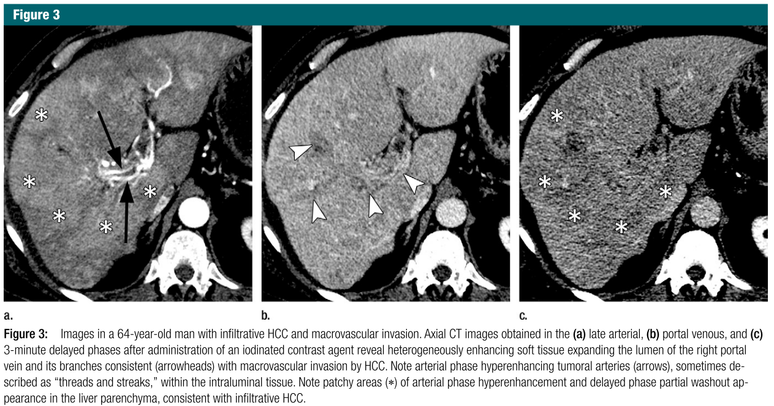
- In order to fully understand the behavior of HCC cells, one can use extracellular agents as explained above, or use intracellular agents. In the latter case, hepatobiliary agents allow a better diagnosis through understanding the hepatocellular function in addition to the vascularity information. These agents first enhance the extracellular space before entering the hepatocytes through the OATP specific receptors. To acquire this hepatobiliary phase, which can exclusively be obtained on MRI, different agents exist, and they mainly differ in their hepatocellular uptake, thus reaching an enhancement at different moments. In the exception to the delayed phase for some specific agents, the normal phases can be acquired, along with some new phases such as the “transitional phase”, which represent a transition from extracellular-dominant to intracellular-dominant enhancement [ref 116 of Choi et al.].
Unlike extracellular agents, the hepatobiliary contrast agents show promise for differentiating early HCCs and premalignant nodules from lower-risk nodules [ref 31-37 of Choi Part2 et al.].
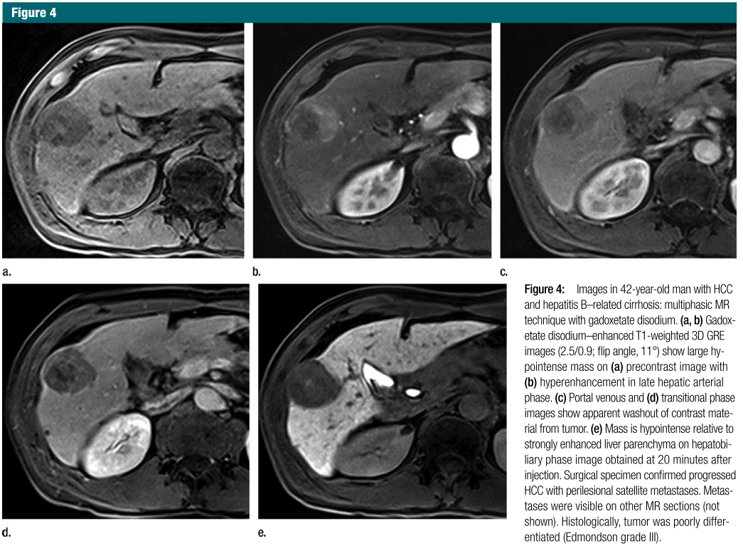
Main advantages of choosing CT over MRI examination is that it is widely available, rapid, robust and requires less expertise than MRI when interpreting images. It however exposes patients to radiation doses, and provides relatively lower soft-tissue contrast than when MRI is used. MRI permits the assessment of a great number of tissue characteristics, but is time-consuming, less robust, and prone to artifacts. Even though MR imaging examination may be preferred at some academic centers, there is no consensus for recommending this modality over CT in community or less-specialized centers [ref Choi et al Part2. 2014 - Heimbach et al. 2017].
Therefore, it has been decided to mainly focus our research work on CT images.

These recent innovations in the medical imaging fields were accompanied by the creation of several clinical criteria that helped the radiologists to take decisions concerning the treatment choice, depending mainly on the characteristics of the tumor.

Staging & Treatment
One of the most widely used criteria for the assessment of HCCs is the BCLC staging system, recently refined by Llovet et al. in 2008 [ref Llovet et al.].
As described in the figure below, the main factors used to build this staging system rely on the tumor status, namely, the number and the size of the nodules, the presence or the absence of vascular invasion and extrahepatic spread. Other characteristics such as the liver function (as defined by the Child-Pugh classification [ref Pugh et al. 1973] , the potential presence of portal hypertension and both serum bilirubin and albumin levels), and an indicator called the general performance status describing the overall level of functioning of the patient [ref ECOG].
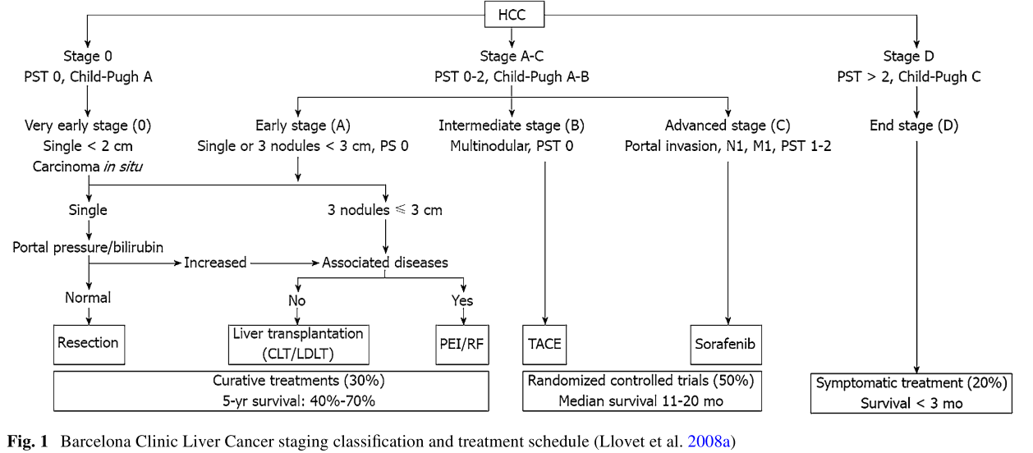
These criteria were developed to support previous staging systems such as the TNM as depicted below, that was introduced and refined by the AJCC, and it incorporated some independent work such as the Milan criteria which concerns only a specific subtype of the TNM staging system [ref Mazzaferro et al].
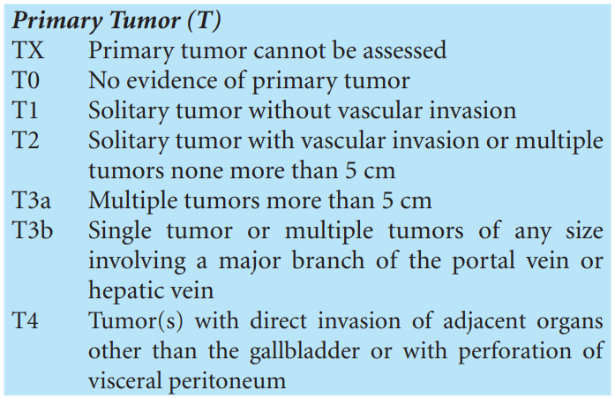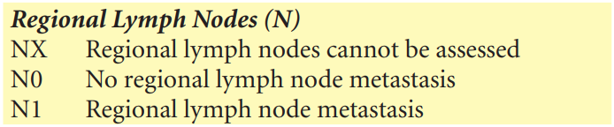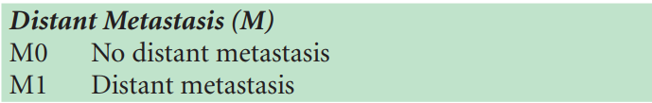
One of the main advantages brought by the BCLC staging system is to provide strong guidelines concerning the treatments to follow depending on the disease progression.
Hereafter, we detail the different treatment techniques available for patients suffering from HCCs when seeking for curation:
- Surgical resection, where the best candidates are patients with solitary tumor and preserved liver functions [Fornet et al. 2018].
A resection is defined as curative if all macroscopic evidence of primary and second tumor are detected in the remnant liver or in any other organs by dynamic CT or MR within 4 weeks after surgery [Yang et al. 2012].
As mentioned by previous studies, resection remains the treatment of choice in patients without cirrhosis suffering from HCC. Patients with cirrhosis have to be carefully selected to reduce the risk of postoperative liver failure [ref 8, 29, 30 of Breen et al. 2015].
- Liver transplantation, which mainly benefits patients who are not good candidates for surgical resection, and fits better those within the Milan criteria (solitary tumor up to 5cm or less than 3 nodules measuring each one less than 3cm) [Llovet et al. 2012 + ref 177]. In theory the transplantation may cure the tumor and the underlying cirrhosis at the same time, however, this procedure suffers from a scarcity in terms of donors, with an increase in the waiting time that led up to 20% of the potential receivers to drop out of the list before finding a donor, even with the existence of bridge therapies that can preserve the patient health during the waiting time [ref 161 of Llovet et al.].
Some modifications have been done to the initial inclusion criteria for the transplant candidates after poor recurrence results were obtained. [Llovet et al. 2012]
- Image-guided ablation (IGA) is the most frequently used therapeutic strategy but its efficacy is limited by the size of the tumor and its location.
This technique belongs, just like resections, to primary line treatments for patients with early stage HCC (BCLC stage 0-A) for whom surgical management is contraindicated [Heimbach et al. 2017 - ref 8 of Breen et al. 2015]. It has also been noticed that patients with very small HCCs (less than 2cm in diameter) can benefit from IGA to avoid any surgical procedure [ref 9 of Breen et al.].
Several methods have been developed to perform the destruction of the tumor, and radiofrequency ablation (RFA) remains the most popular technique. Other techniques (thermal or non-thermal) have been adopted to overcome limitations of RFA.
The risk of complications is higher when the procedure is performed on tumors located along the surface of the liver. Indeed, puncture can cause bleeding, and heating can cause complications by provoking injury on adjacent organs. The intervention should be performed by an oncologist with sufficient experience, in order to assess the risk of causing damages to the gastrointestinal tract [ref Breen et al.].
However, RFA techniques have recently been improved by the assistance of 3D navigation systems, allowing better planning with multiple overlapping ablation zones, a more accurate placement of the probes and an assessment of the results intraoperatively, thanks to image fusion. This new generation of techniques is called “stereotactic RFA” [Bale et al. 2019, Laimer et al. 2019 - Perrodin et al. 2019].
Therefore, the question whether to choose resection over RFA is still open [Heimbach et al. 2017 - Bale et al. 2019].
- Transarterial Chemoembolization (TACE), which has survival benefits in asymptomatic patients with multifocal disease without vascular invasion or extrahepatic spread can also be considered [ref Fornet et al. 2018].
TACE can also be applied to patients in earlier stages, who are not suitable for the other therapeutic available treatments. This clinical situation is known as “treatment stage migration” and reflects a certain flexibility in the BCLC clinical interpretation [Burrel et al, 2012].

The same staging systems are used for the patient follow-up, and can be supported by other metrics such as the RECIST (standing for “Response evaluation criteria in solid tumours”) which assess the tumor response, but presents several limitations and has already been modified in the past to incorporate changes [ref Eisenhauer et al. 2008].

As explained here, general staging systems rely mainly on the macro changes caused by the disease, ignoring many histological measurements, such as the histological grade, depicted below, and defined following the Edmonson-Steiner grading system, corresponding to the level of cellular differentiation [ref Edmonson 1954]:
- G1: Well differentiated
- G2: Moderately differentiated
- G3: Poorly differentiated
- G4: Undifferentiated

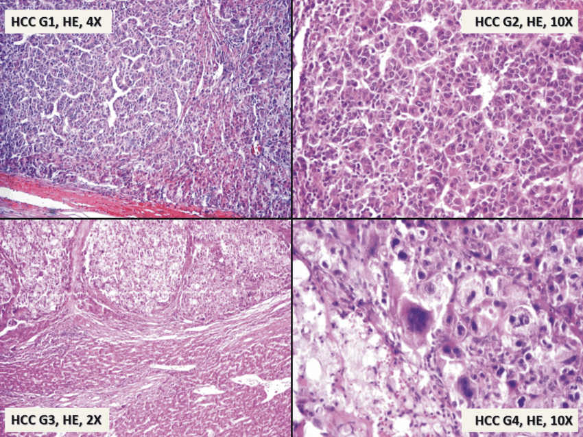
Histological grades as illustrated by Turdean et al. 2012 [ref Turdean et al. 2012]

Current methods to evaluate the tumor and to propose the best available treatment still suffer from a lot of limitations, especially because they rely on subjective interpretation of images, or clinical data, and also because of the discrete staging systems that are used in a clinical routine.
The main hypothesis of our research work is that medical images can be enhanced to provide a subjective feedback to the clinicians, and help them with non-invasive tools to give to patients suffering from HCCs the best chances of survival.
(Add a short introduction to radiomics here)*

